Execution of DML operations and queries
  - As asked here are the executed outpul for all DML operations and queries in the form of logs
1-
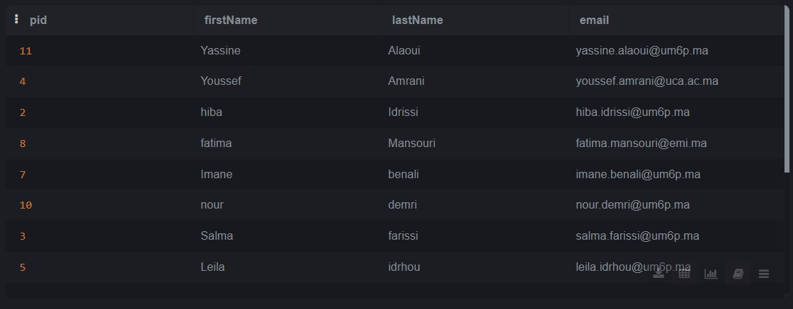

2-

3-
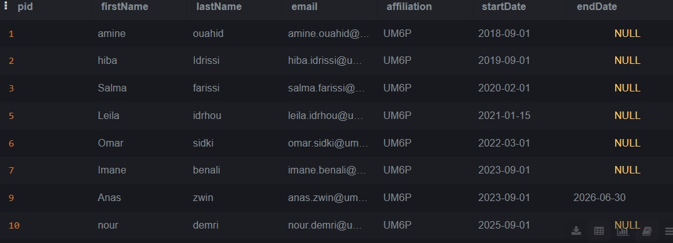
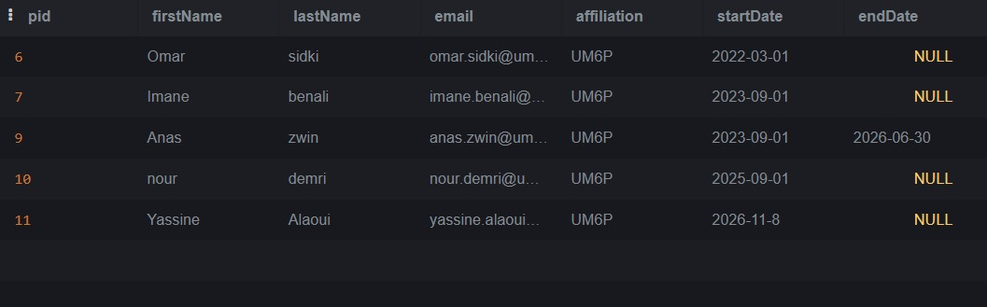

4-
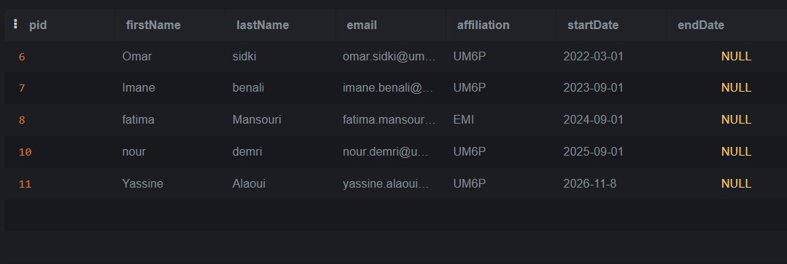
5-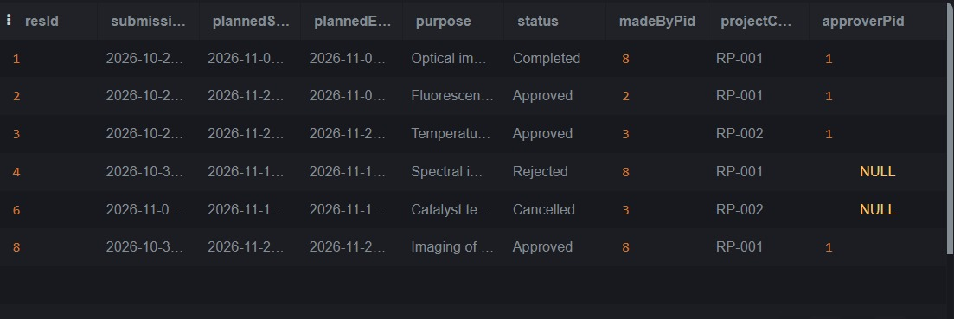
6-
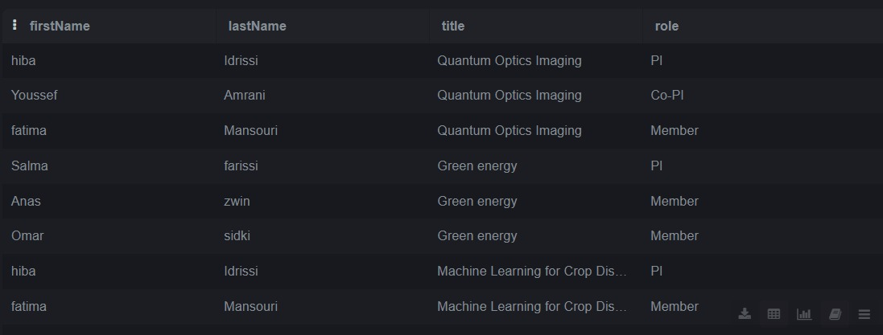
7-
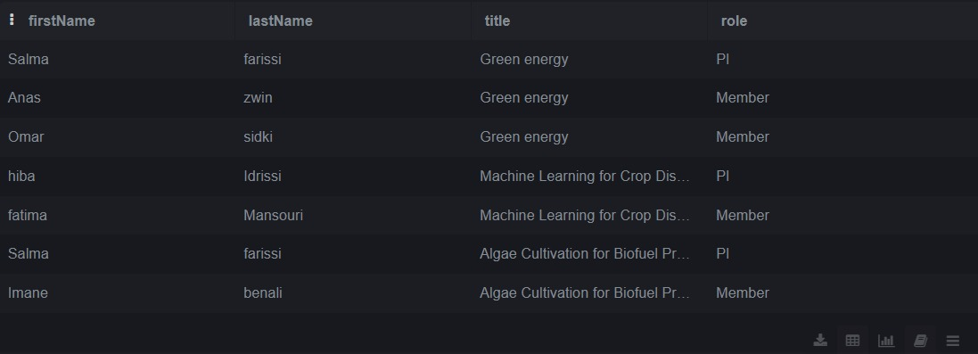
8-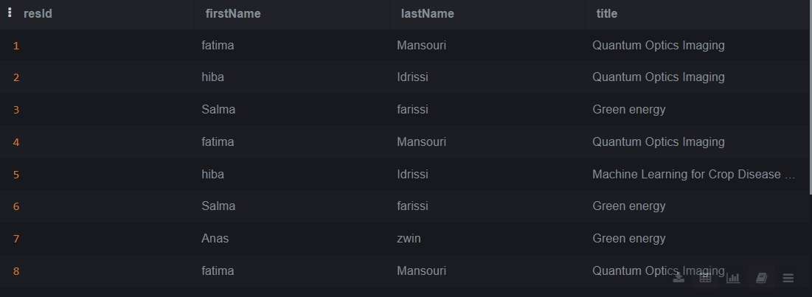
9-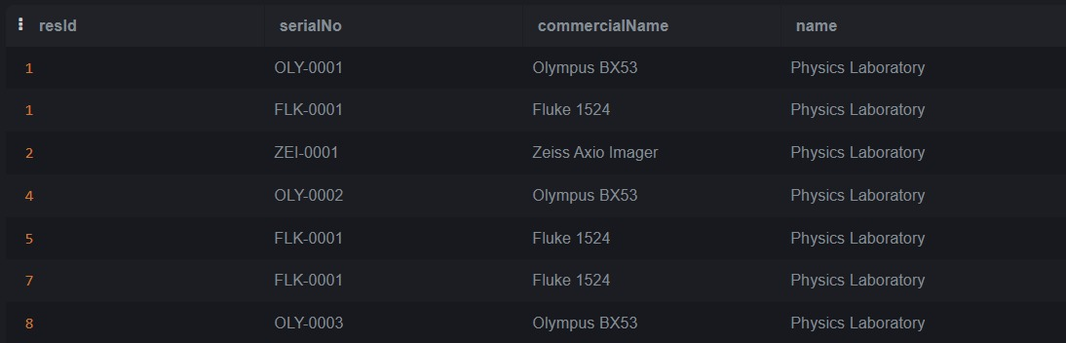
10-

11-
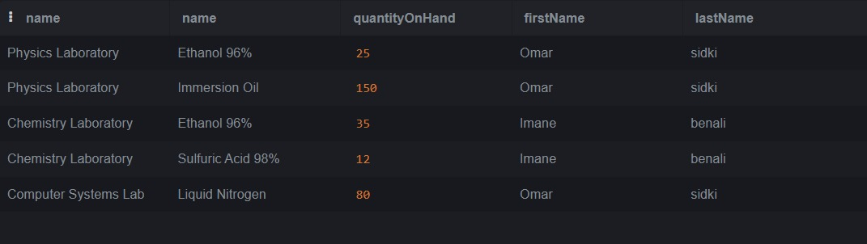
12-
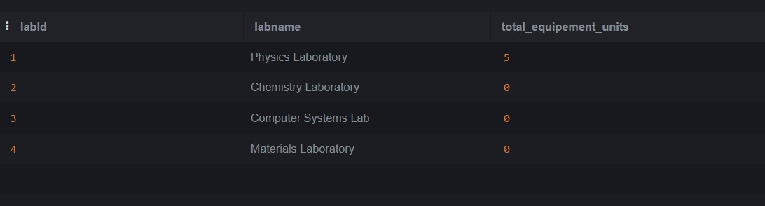
13-
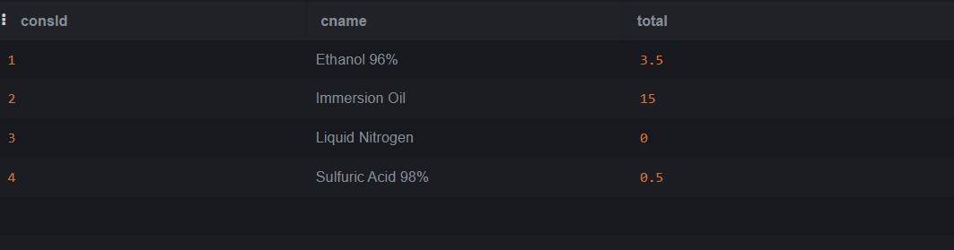
14-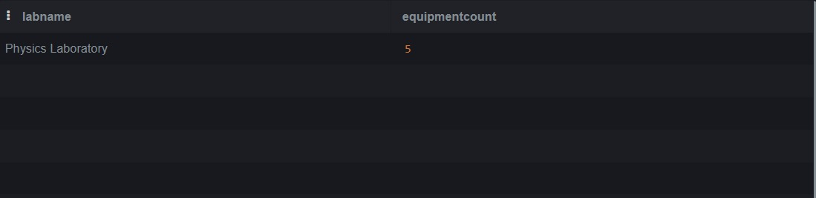
16-
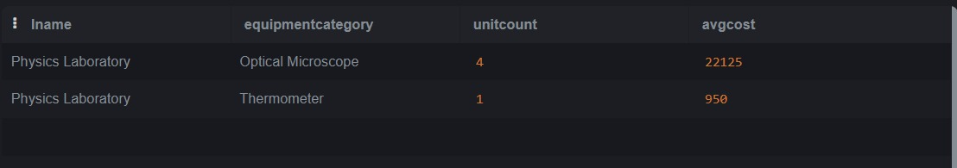
17-
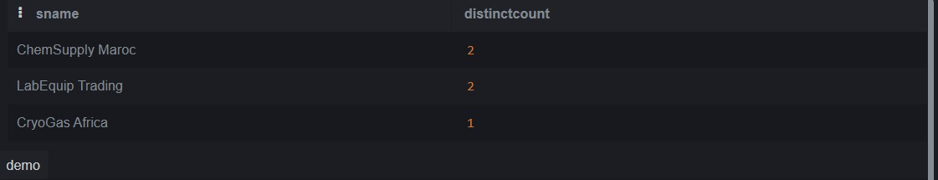
20-
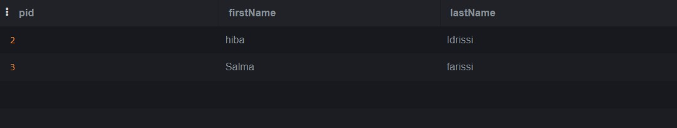
21-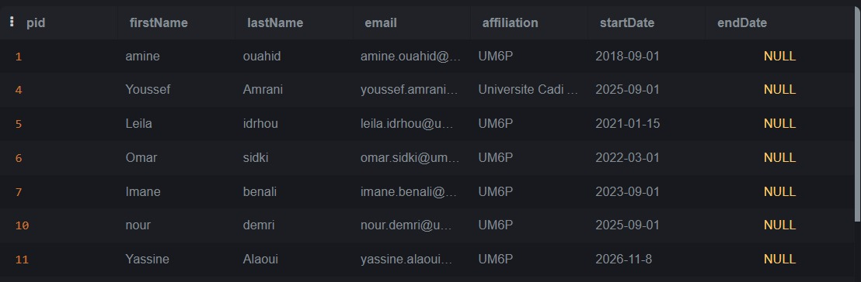
22-
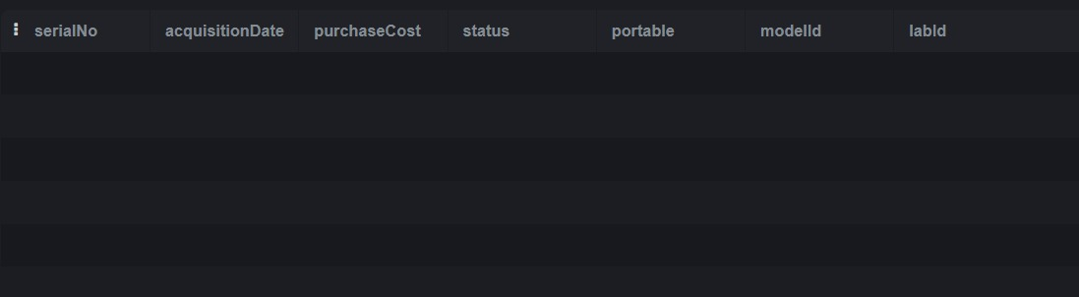
24-


